**Installation instruction**

1. Create folder for support exceedvote and then download exceed project and save in folder that you created.
2. Open a **command prompt** or **terminal** and **cd** to your **folder that you create**

|  |
| --- |
| Example : cd /Users/prisadumrongsiri/Desktop/Air-Team/ExceedVote |

1. Type this in and press enter:

|  |
| --- |
| java -cp "dist/*" exceedvote.air.model.Main |

If you see your program running, then it is working

**YOU will see the application run**

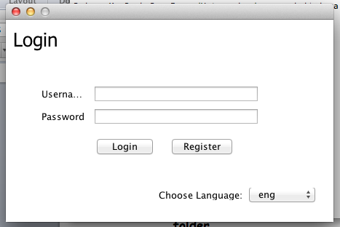

**All library**

|  |  |
| --- | --- |
| * derby.jar – Derby Database |  |
| * eclipselink.jar - JPA 2.0 reference implementation |  |
| * log4j-1.2.17.jar - Apache Software Foundation Logging Project |  |
| * javax.persistence_2.0.4.v201112161009.jar – JPA - The javax.persistence package |  |
| * exceedvote.jar – Main Application |  |